Oracle Payroll
How to pay third parties from voluntary deductions.
Creation Date: Jan 25, 2022

AUSTIN ARK
Plaza 7000 North Mopac Expressway
Suite 200
Austin, Texas – 78731
Email: contact@austinark.com

Creation Date: Jan 25, 2022

Table of Contents
Overview................................................................................................................................................................ 3
Purpose.................................................................................................................................................................. 3
Business Case......................................................................................................................................................... 3
Creating Third-Party Payment using Voluntary Deductions................................................................................... 4 Steps to create Third-Party Payment using Voluntary Deductions…………………………………….................................. 4 Modify the Calculator Formula.............................................................................................................................. 5 Modify the Status Processing Rule of the Calculator Element……......................................................................... 6 Add balance feed to Third Party Payment Balance............................................................................................... 7 Third-Party data Table details…………. ................................................................................................................... 7

Overview
This guide demonstrates the necessary steps to generate a check for third parties from employees’ salaries as a voluntary deduction.
Purpose
This document details the steps to generate checks for the third party from an employee’s salary as a voluntary deduction. This document also provides all the required pre-requisite steps and configuration. Tips on how to prepare the Voluntary deduction element, how to convert it to a third party.
Business Case
This is a common situation when an organization tries to pay the voluntary deduction of an employee to a third party through check payment. We cannot achieve this with the delivered Voluntary deduction setup from the system. As the delivered system only deduct the voluntary deduction from the employee’s salary.
As a Payroll Administrator, they would like to modify the system to generate the check to third parties from voluntary deductions in each pay cycle. This document provides the detailed steps to handle this kind of situation.

Creating Voluntary Deduction Element
Note: If you already have an Administrative Life Event, you do not have to create a new one

Third-Party Payment using Voluntary Deductions

Step 1: Create a Voluntary Deduction element
Step 2: Change the Priority of the Calculation and Result element (This is to provide the Indirect Result in SPR)

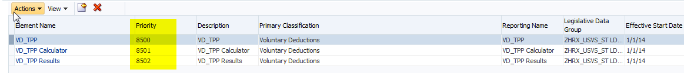

Step 3: Create an Input Value called ‘Payee’ for the Base element with the Third-Party Context and Special Purpose value set.

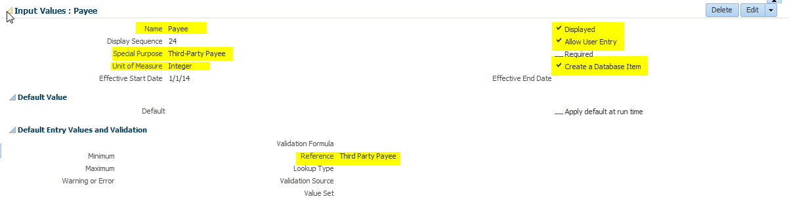

- We need to select UOM as Integer so that the Third-Party Payee Reference will be displayed.
- Value Set for the Payee name cannot be used as they are enabled only for Characters.
- Database Item is being created to be used in Formula.
Step 4: Create a similar input value for the Results element as well.
- Input Value at the base element is for the end-user to enter the value
- Input Value at the Result Element is for the Balance Feed

Step 5: Modify the Calculator Formula: Add these statements highlighted below.

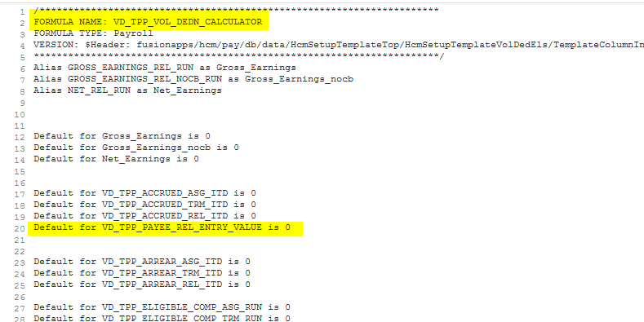

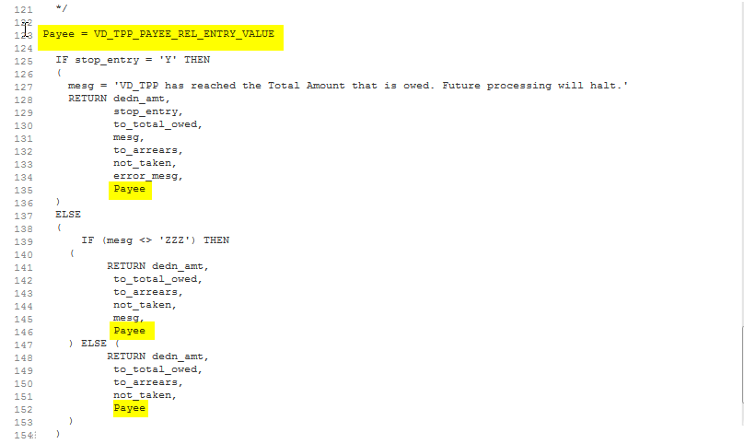

Note:
If the element was created at the Payroll Relationship level, then the DBI should be <element name>_REL_ENTRY_VALUE.
If the element was created at Assignment Level, then the DBI should be <element name>_ASG_ENTRY_VALUE.
Step 6: Modify the Status Processing Rule of the Calculator Element
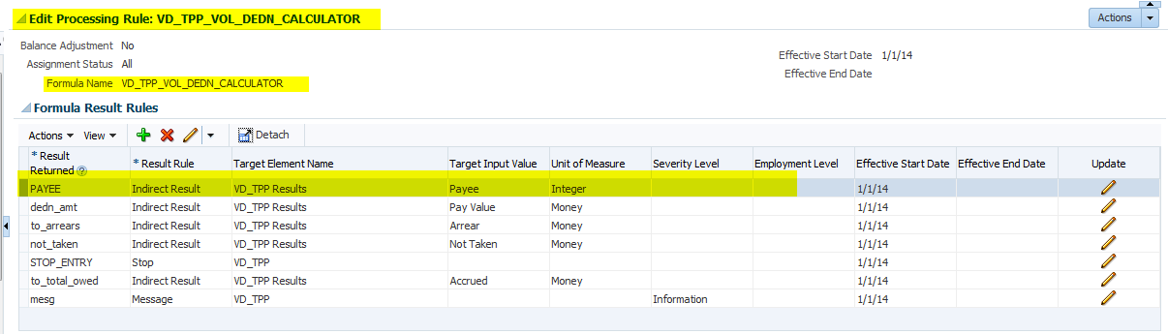

Add the Payee as an Indirect Result to Results element

Step 8: Add balance feed to Third Party Payment Balance
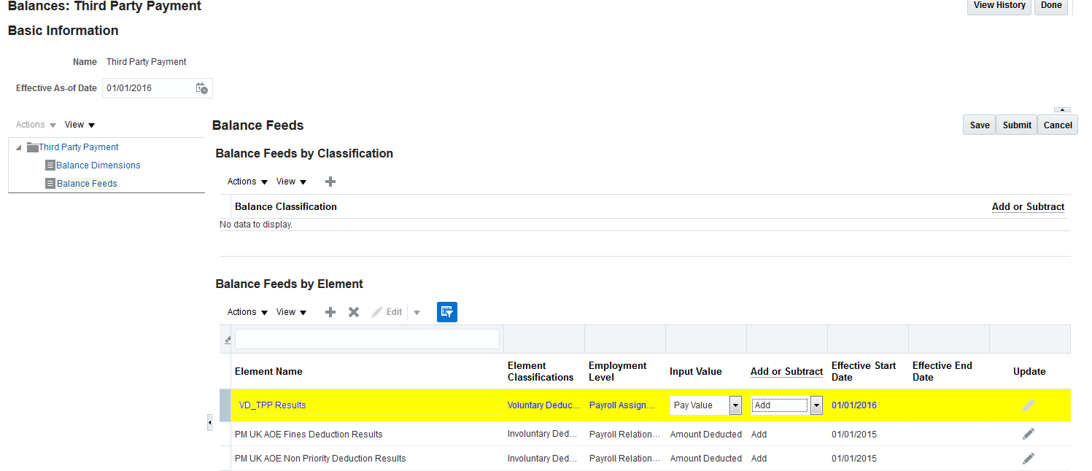

Step 7: Assign this element to the employee and provide the input Value and Third-Party Payee id as value for ‘Payee’

Third-Party Payee ID can be obtained for hz_parties table or PAY_ORG_PAY_METHODS_F or PAY_PERSON_PAY_METHODS_F

